Predictive Model Plan – Student Template

1. Model Logic (Generated with GenAI)
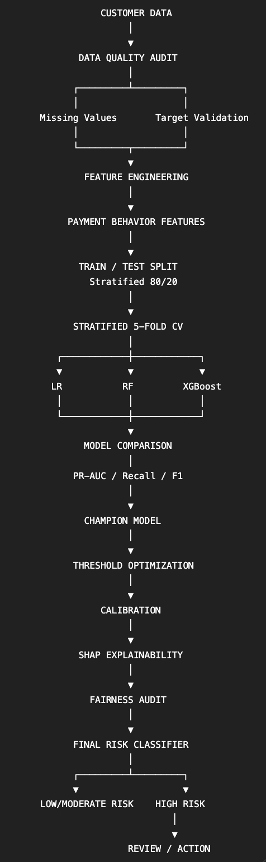

The model is designed to predict whether a customer is likely to become delinquent based on available customer, financial, credit, and payment-related attributes. The predicted probability can be converted into a risk classification to support early identification and appropriate customer-risk management.

2. Justification for Model Choice

Model | Role | Why included
Logistic Regression | Baseline | Highly interpretable and appropriate for financial risk
Random Forest | Nonlinear benchmark | Captures nonlinear relationships and interactions
XGBoost | Advanced candidate | Strong gradient-boosting algorithm for tabular data
The final model will not be selected solely on accuracy. The three models will be compared using stratified cross-validation, with particular emphasis on PR-AUC, recall, F1-score and ROC-AUC because delinquency is a minority class. The model demonstrating the best balance between predictive performance, interpretability, and business suitability will be selected as the champion model.

3. Evaluation Strategy
The models will be evaluated using a stratified 80:20 train-test split and 5-fold stratified cross-validation to ensure that the minority delinquency class is adequately represented during training and validation. Since delinquent accounts represent a minority class, accuracy alone will not be used as the primary evaluation metric.
PR-AUC will be prioritized for evaluating the model's ability to identify delinquent customers, while ROC-AUC will measure the overall ability to distinguish between delinquent and non-delinquent customers. Precision will indicate how many customers flagged as delinquent are actually delinquent, while recall will measure how many actual delinquent customers are successfully identified. F1-score will provide a balance between precision and recall. A confusion matrix will also be reviewed to understand false positives and false negatives.
The classification threshold will be reviewed and optimized based on the business objective, particularly the trade-off between missing delinquent customers (false negatives) and incorrectly flagging non-delinquent customers (false positives).
To assess fairness, model performance will be compared across relevant customer groups using metrics such as recall, precision, false-positive rate, and false-negative rate. Any significant disparities will be investigated before deployment. SHAP-based explanations will be used, where applicable, to understand the key factors contributing to individual predictions and improve model transparency.
From an ethical perspective, the model should be used as a decision-support tool rather than as the sole basis for adverse customer decisions. Customer data should be handled securely, sensitive attributes should not be used inappropriately, and human oversight should be maintained for high-impact decisions.
4. Dataset Limitation
During implementation, the supplied dataset produced relatively weak predictive performance across the evaluated models. The cross-validation ROC-AUC values were close to random classification, and the final test results showed limited ability to identify delinquent accounts. This suggests that the available features may contain limited predictive signal for the supplied delinquency target. As the dataset was provided as part of the assignment, it has been retained without modification. Therefore, the current results should be interpreted as an assessment of model performance on the provided data rather than as evidence of production-ready delinquency prediction. In a real-world setting, additional historical payment behavior, credit information, and validated outcome data could be considered to improve predictive capability.

